Ex no: 13

Date:

**SIMPLE PROGRAMMING EXERCISE USING (REPEAT, WHILE)**

**AIM:**

To write a function to build a string repeatedly and use select statement.

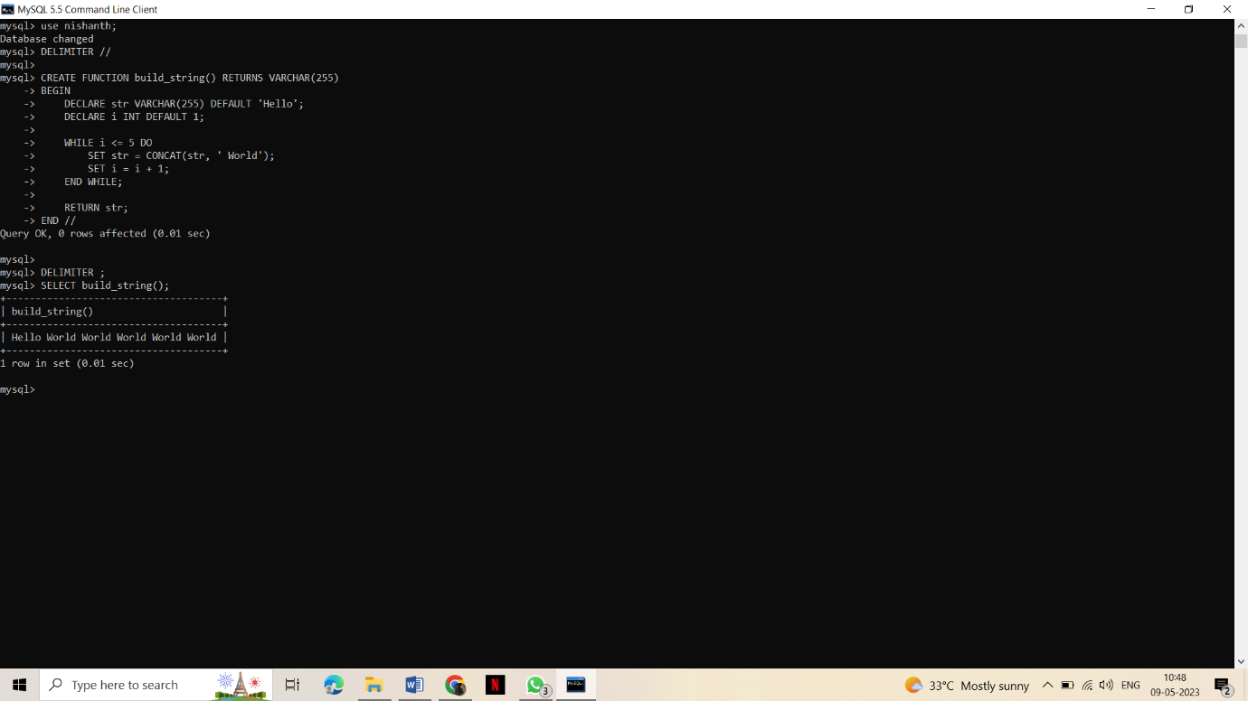

**Result:**

A function to build a string repeatedly and use select statement is successfully verified and executed.